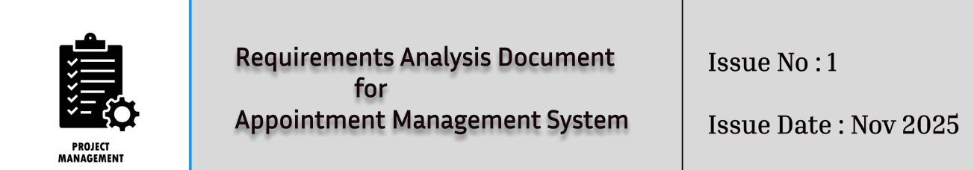

Requirements Analysis Document
for
Appointment Management System

Issue Number : 1
Issue Date : 7.11.2025

Prepared by
Husniddin Ramazanov
Kamil Duru
Mustafa Balaban
Onur Bilgin

Github: https://github.com/Mbalaban1776/Appointment-Manager-System



TABLE OF CONTENTS
1 Introduction 3
1.1 Purpose of the system 3
1.2 Scope of the system 3
1.3 Objectives and success criteria of the project 3
1.4 Definitions, acronyms, and abbreviations 4
1.5 References 4
1.6 Overview 4
2 Current system 5
3 Proposed system 5
3.1 Overview 5
3.2 Functional requirements 5
3.3 Nonfunctional requirements 8
3.3.1 Usability 8
3.3.2 Reliability 9
3.3.3 Performance 9
3.3.4 Supportability 10
3.3.5 Implementation 10
3.3.6 Interface 10
3.3.7 Packaging 11
3.3.8 Legal 11
3.4 System models 11
3.4.1 Scenarios 11
3.4.2 Use case model 13
3.4.3 Object model 14
3.4.4 Dynamic model 15
3.4.5 User interface 16
4 Glossary 17



1. Introduction

1.1 Purpose of the system

The primary purpose of the Appointment Management System (AMS) is to address the operational inefficiencies faced by small service sector businesses (such as salons, spas, clinics, and repair shops). It aims to provide a centralized platform for managing core operational resources (personnel and equipment) and services. The system will streamline scheduling and resource allocation to ensure services are delivered to clients in a timely and organized manner.

1.2 Scope of the system

The AMS will encompass the full lifecycle management of resources, services, staff schedules, and client bookings. The system's scope includes the provision of an accessible web application and a dedicated mobile application for staff and clients to ensure convenient interaction at any time.

1.3 Objectives and success criteria of the project

Objectives:
- To efficiently allocate resources (personnel and equipment) to appointments, avoiding conflicts or overbooking.
- To maintain accurate personnel time management, including shift scheduling, breaks, and leave.
- To provide clients with a smooth and interactive online booking experience via web and mobile apps.
- To generate actionable reports and automated notifications for key scheduling events.
Success Criteria:
- Successful implementation of all CRUD (Create, Read, Update, Delete) operations across resources, services, clients, and appointments.
- Demonstrated real-time data synchronization between web and mobile platforms to reflect instant updates.
- The implemented interface is intuitive and requires minimal training for business staff.

1.4 Definitions, acronyms, and abbreviations

AMS: Appointment Management System.
CRUD: Create, Read, Update, Delete.
Resource: Any item required to deliver a service, categorized as human personnel
(e.g., stylists, technicians) or specialized equipment (e.g., laser machine).
Client: A customer whose profile and booking history are maintained by the system.
Synchronization: Real-time data consistency between the web and mobile platforms.

1.5 References

- Client Problem Statement: "Appointment Management System for Small Service Sector Businesses" (Appointment Management System.docx).
- Assignment Instructions: "CSE443 Assignment #1 Requirements Analysis Document."
- Wikipedia
- Medium
- Gemini
- ChatGpt
- Figma

1.6 Overview

This document presents the Requirements Analysis Document (RAD) for the Appointment Management System (AMS).
The AMS is being developed to resolve operational inefficiencies like overbooking and resource underutilization experienced by small service sector businesses. The system's primary goal is to provide a centralized platform for managing resources (personnel and equipment) and services.
The scope of the system covers the full lifecycle management of resources, services, staff schedules, and client bookings, accessible via both a web application and a dedicated mobile application.
Key objectives include efficient resource allocation to avoid conflicts, maintaining accurate personnel time management, and delivering a smooth, interactive online booking experience for clients.
Project success will be measured by the successful implementation of CRUD operations across all data entities and the achievement of real-time data synchronization between all platforms.

2. Current System

Currently, the tasks supported by the new system are accomplished through manual
processes (pen and paper, spreadsheets) or the use of generic scheduling tools. These
existing methods are problematic because they:
- Lack essential features for managing diverse resources and handling multiple service types with varying durations.
- Do not support real-time synchronization across devices or accessible options for clients to book services online.
- Often result in overbooking, underutilization of resources, and operational inefficiencies that negatively impact customer loyalty.
- If they forget to note that appointment somewhere, user can be disappointed
Like that to many examples we can say.

3. Proposed System

3.1 Overview

The proposed Appointment Management System (AMS), codenamed AppointPro during development, is a comprehensive, centralized, and digital solution designed specifically to replace the fragmented manual or generic scheduling methods currently used by small businesses in the service sector (e.g., salons, clinics, spas).
The core objective of the AMS is to optimize resource utilization, streamline the booking process, and significantly enhance client satisfaction and loyalty by eliminating scheduling conflicts and providing 24/7 accessibility.

3.2 Functional requirements

Functional Requirements define the core actions and capabilities the Appointment Management System (AMS) must provide to its users. They are categorized based on the major areas of the system functionality.
Resource Management (FRM)
This module manages all bookable entities, including personnel and equipment.
FRM-100 | Resource CRUD Operations | The system must allow authorized users (Admin/Manager) to Create, Read, Update, and Delete resources.
FRM-101 | Personnel Calendar Definition | The system must allow managers to define and manage staff schedules, including shifts, breaks, time-off requests, and capacity constraints.
FRM-102 | Resource Type Specification | The system must allow resources to be categorized by Type (Human Personnel or Equipment) and define specialized qualifications or maintenance needs.
FRM-103 | Availability Tracking | The system must maintain a dynamic calendar view of resource availability, tracking active working hours and downtime blocks (e.g., maintenance).
FRM-104 | Conflict Alerting | The system must automatically notify managers of potential overbooking risks or underutilization based on staff schedules and appointment loads.

Service Catalog Management (FSC)
This module handles the definition and management of all services offered by the business.

FSC-200 | Service CRUD Operations | The system must allow authorized users (Admin/Manager) to Create, Read, Update, and Delete service definitions.
FSC-201 | Service Detail Specification | The system must store core service attributes, including Name, Description, Estimated Duration, Price, and required Resource List.
FSC-202 | Service Categorization | The system must allow services to be organized into user-defined categories (e.g., Hair, Nails, Massage) for easier client navigation.

Appointment Handling and Scheduling (FAS)
This is the core module for booking, viewing, and managing all client appointments.
FAS-300 | Appointment Creation (Staff) | Staff must be able to book appointments manually by selecting a service, client, preferred resources, date, and time.
FAS-301 | Appointment Creation (Client) | Clients must be able to book appointments online via the web/mobile app by selecting a service, viewing available slots, and confirming the booking.
FAS-302 | Real-Time Conflict Check | The system must perform a dynamic availability check across all required resources and personnel before confirming a booking.
FAS-303 | Appointment Visualization | The system must display appointments in calendar and list formats (Day, Week, Month) with filtering capabilities by resource, service, or client.
FAS-304 | Appointment Modification | Authorized users must be able to Reschedule, Reassign personnel/equipment, and Modify service notes for existing appointments.
FAS-305 | Cancellation Management | The system must allow clients (if enabled) and business staff to Cancel appointments, triggering necessary confirmation notifications.
FAS-306 | Recurring Appointments | The system must support the booking and management of recurring appointments based on defined intervals.

Client Management (FCM)

This module ensures the business can maintain a centralized database of customer information and history.

FCM-400 | Client CRUD Operations | The system must allow authorized users to Create, Read, Update, and Archive client records.
FCM-401 | Client History Tracking | The system must automatically track and display a full booking history, service preferences, and notes associated with each client record (CRM-style).
FCM-402 | Client Self-Service | Registered clients must be able to access and update their contact information and view their upcoming and past appointments.

3.3 Nonfunctional requirements

Nonfunctional requirements describe the user-level expectations that are not directly related
to functionality but pertain to the overall quality and system constraints.

3.3.1 Usability

The user interface (UI) and user experience (UX) must ensure ease of use and navigation
across all user roles (Client, Staff, Administrator).

ID | Nonfunctional Requirement | Justification based on Mock-ups
U1 | The overall system design shall utilize a clear, modern, and consistent visual language (e.g., card-based layout, consistent color palette) across all screens. | The mock-ups utilize a unified, card-based interface with clear navigation menus.
U2 | The administrator dashboard shall present key operational metrics (e.g., today's appointments, attendance rate, daily revenue) within a single glance for rapid decision-making. | The "Manager Dashboard Examples" clearly display summarized data in prominent cards.
U3 | The system shall provide clear, role-based access control management through an intuitive form, ensuring personnel can easily assign granular permissions (e.g., Staff Management, Financial Access). | The "Manager Role Management" screen uses checkboxes to allow non-technical staff to easily assign permissions.
U4 | The client booking flow shall minimize input steps, allowing users to rapidly select service type, preferred date, and book an appointment from the main portal. | The "Quick Booking" widget shows a simple three-field approach for fast reservations.

3.3.2 Reliability

The system must ensure data accuracy, resource availability, and operational stability.

ID | Nonfunctional Requirement
R1 | The system shall maintain 99.9% uptime during defined business hours.
R2 | The database shall enforce data integrity constraints to prevent concurrent bookings on the same resource (personnel or equipment) during overlapping time slots.
R3 | The system must include a robust data backup and recovery mechanism (e.g., the "Auto Backup" feature seen in the "Global Settings") to ensure service data can be restored within 2 hours of a catastrophic failure.

3.3.3 Performance

The system must respond quickly to user interactions, especially during critical operations.

ID | Nonfunctional Requirement
P1 | The system shall load the Manager Dashboard and display all aggregated daily metrics within 2 seconds.
P2 | The API response time for dynamically checking resource availability during the client booking process shall not exceed 500 milliseconds.
P3 | The system must be scalable to handle up to 1,500 active users and process 5,000 bookings per week without performance degradation.

3.3.4 Supportability

The system must be easily maintainable and provide necessary insights for troubleshooting.

ID | Nonfunctional Requirement
S1 | The system shall provide a clear "System Health" status that monitors the server, database connection, and API response time.
S2 | The system shall maintain detailed audit logs for all changes made to resource schedules and client appointments for simplified troubleshooting and accountability.

3.3.5 Implementation

This covers technology stack and deployment decisions.
ID | Nonfunctional Requirement
I1 | The application shall be developed using a responsive design methodology to ensure full functionality across desktop, tablet, and mobile devices.
I2 | A RESTful API shall be implemented as the backend communication layer to ensure data is efficiently exchanged between the database and the front-end clients.

3.3.6 Interface

This covers external system integrations.
ID | Nonfunctional Requirement
IF1 | The system shall utilize external services (e.g., Twilio for SMS) to send notification reminders to clients and staff.
IF2 | The system shall support payment gateway integration to process payments (as implied by the "Process Payments" and "Daily Revenue" indicators).

3.3.7 Packaging

The system shall be hosted on a cloud infrastructure to ensure scalability and global accessibility.

3.3.8 Legal

L1 - The system shall implement strong authentication (e.g., JWT) and authorization controls
to strictly enforce role-based permissions defined in the "Manager Role Management"
screen.
L2 - The system shall encrypt client personal and financial data both in transit and at rest to
comply with data privacy regulations.

3.4 System models

3.4.1 Scenarios

Scenario 1 – Client Books a New Appointment
Primary Actor: Client
Goal: Book a preferred service at a convenient time.
Pre-condition: Client has internet access and the business schedule contains available slots.
Main Flow:
1. The Client opens the web or mobile application and navigates to “Book Appointment.”
2. The system displays a list of available services categorized by type
3. The Client selects a service and optionally chooses preferred personnel or lets the system auto-assign.
4. The system checks resource availability in real time and shows available date/time slots.
5. The Client selects a slot and confirms the booking.
6. The system creates the appointment, updates the calendar, and sends a confirmation via email or SMS.
Post-condition: Appointment record is stored and visible in both client and staff dashboards.
Scenario 2 – Admin Manages Personnel and Equipment
Primary Actor: Administrator / Business Owner
Goal: Add new staff member and schedule equipment maintenance.
Pre-condition: Admin is authenticated in the system.
Main Flow:
1. Admin opens the “Resource Management” module.
2. Admin selects “Add Personnel” and enters details
3. The system saves the record and updates the availability calendar.
4. Admin switches to the “Equipment” tab and marks a machine as under maintenance for a given period.
5. The system blocks those time slots for that equipment to prevent conflicts.
Post-condition: Personnel and equipment records are updated; future bookings respect these changes.
Scenario 3 – Staff Views Daily Schedule and Performs Service
Primary Actor: Staff Member (
Goal: Check assigned appointments and update status.
Pre-condition: Staff is logged in and has existing bookings for the day.
Main Flow:
1. Staff opens the dashboard and selects “Today’s Appointments.”
2. The system displays a chronological list with client names, service types, and start times.
3. Staff selects an appointment to view details or mark progress.
4. After completing the service, staff marks it as “Completed.”
5. The system updates status and notifies the client that the service was delivered.
Post-condition: Appointment status = Completed; system logs time and resource usage for reports.
Scenario 4 – Client Cancels Appointment and System Notifies Waitlist
Primary Actor: Client
Goal: Cancel an upcoming appointment and notify interested clients on the waitlist.
Pre-condition: A valid confirmed appointment exists.
Main Flow:
1. The Client navigates to “My Appointments” and selects the booking to cancel.
2. The system asks for confirmation.
3. Client confirms cancellation.
4. The system updates appointment status to “Cancelled,” frees the resources, and sends a confirmation notification.
5. If a waitlist exists for that time slot, the system automatically notifies the first client on the list of the new availability.
Post-condition: Resources are freed; waitlisted client has the option to book the slot.

3.4.2 Use Case Model

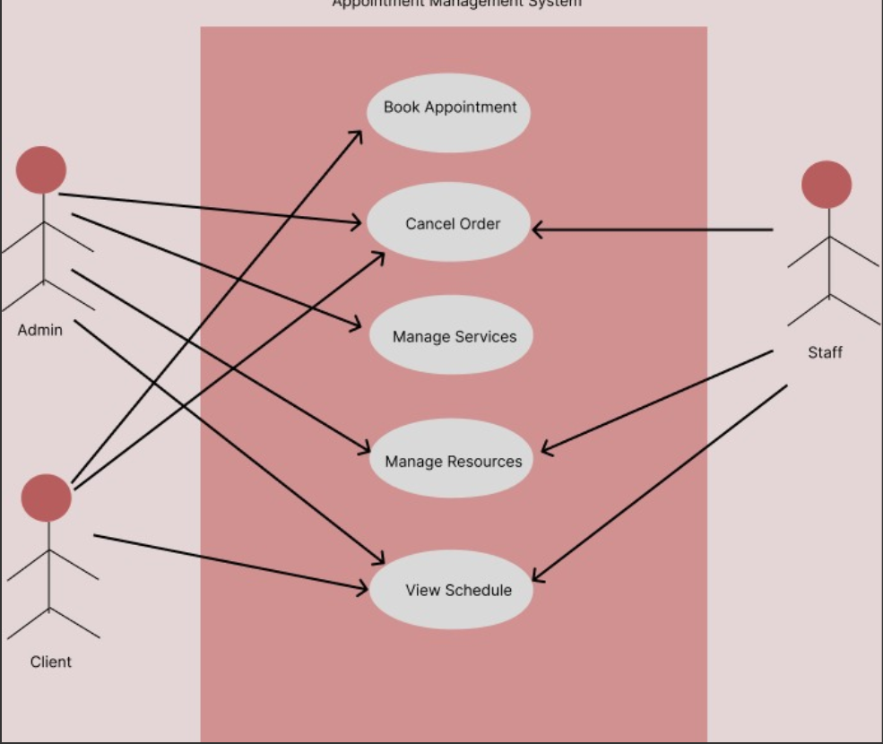

3.4.3 Object Model

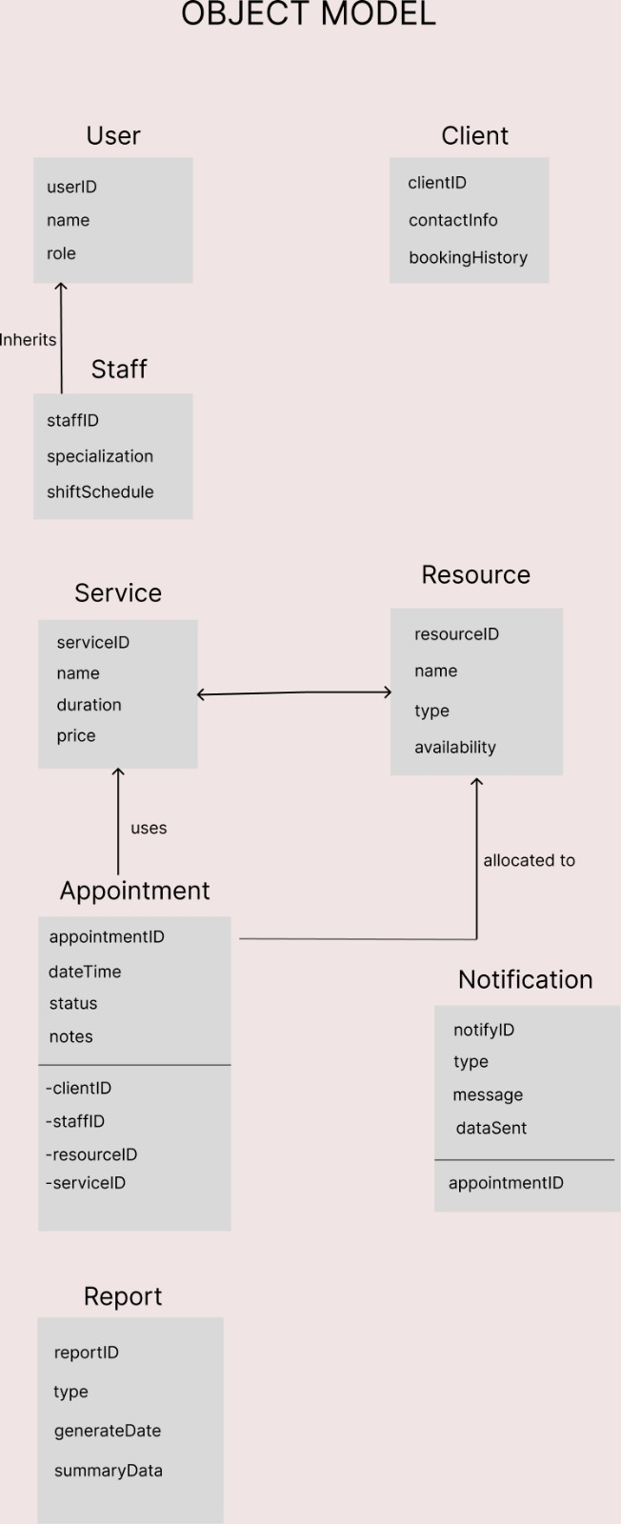

3.4.4 Dynamic Model

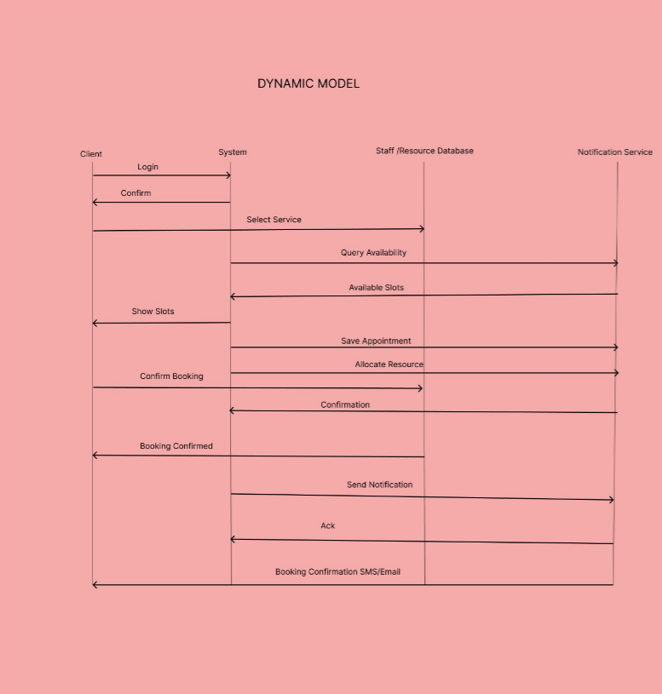

3.4.5 User Interfaces and Mock-ups

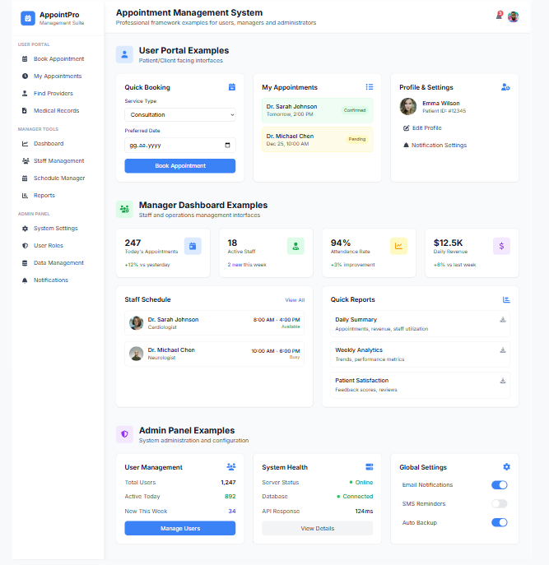

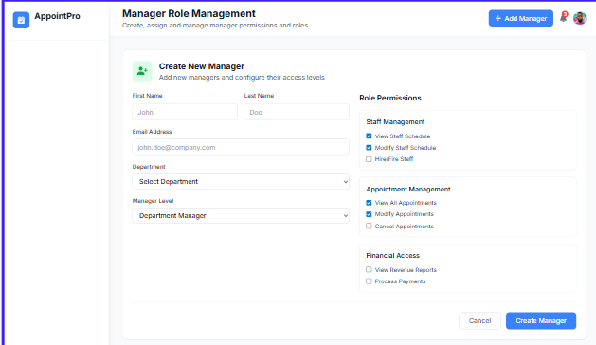

4. Glossary
This section defines important terms, acronyms, and concepts used throughout the Requirements Analysis Document (RAD) to ensure clarity and consistency for all stakeholders, including the development team and the client.
- Administrator (Admin): A system user role with the highest level of permissions, as implied by the "Admin Panel Examples" (Section 3.4.5). This role is responsible for system configuration, user management, and global settings.
- AMS (Appointment Management System): The title of the project. It is the software system being developed to provide a centralized platform for small service businesses to manage resources, services, and client bookings (Section 1.1).
- Appointment: The core entity in the system representing a scheduled booking. It links a specific Client and Service to required Resources (both Personnel and Equipment) at a specific date and time (Section 3.2.3).
- Client: An end-user of the system who books appointments. As defined in Section 1.4, a client is a customer whose profile and booking history are maintained by the system.
- Conflict: A scheduling error where a resource (Personnel or Equipment) is assigned to two or more appointments at the same time. The system is designed to prevent these via FAS-302 (Real-Time Conflict Check) and FRM-104 (Conflict Alerting).
- CRUD: An acronym for Create, Read, Update, Delete (Section 1.4). This represents the four basic functions of persistent data storage and is a success criterion for the project's core entities.
- Equipment: A sub-type of Resource. It refers to non-human assets required to perform a service, such as a laser machine or a specific repair tool (Section 3.2.1, FRM-102).
- Functional Requirement (FR): A statement that defines a specific function or behavior the system must perform (Section 3.2). In this document, they are categorized by module (e.g., FRM, FSC, FAS, FCM).
- Manager: A user role with elevated permissions to manage schedules, resources, and services, as detailed in the "Manager Dashboard" and "Manager Role Management" mock-ups (Section 3.4.5).
- Mock-up: A visual prototype or design that illustrates the system's user interface. The mock-ups in Section 3.4.5 are used to justify Usability (U) nonfunctional requirements (Section 3.3.1).
- Nonfunctional Requirement (NFR): A requirement that describes how the system should perform a function, defining its quality attributes and constraints rather than specific behaviors. This includes Usability, Reliability, Performance, etc. (Section 3.3).
- Object Model: A conceptual model that represents the main entities (or "objects") of the system and the static relationships between them (Section 3.4.3).
- Overbooking: The problem of scheduling more appointments than the available resources can handle. This is a key problem with the Current system (Section 2) that the AMS aims to solve.
- Personnel: A sub-type of Resource. It refers to human staff members who deliver services, such as stylists, technicians, or doctors (Section 1.4, 3.2.1).
- Resource: A core entity in the system required to deliver a service (Section 1.4). Resources are categorized as either Personnel (human) or Equipment (non-human).
- Scenario: A narrative description of a user interacting with the system to achieve a specific goal (Section 3.4.1). Scenarios are used to illustrate and validate Use Cases.
- Service: A specific offering provided by the business that clients can book (Section 3.2.2). A service has defined attributes such as name, duration, price, and a list of required resources.
- Staff: A general user role for an employee of the business. This role can manage their own schedule and perform services (Scenario 3), but has fewer permissions than a Manager or Admin.
- Synchronization (Real-Time): The process of ensuring data is consistent and instantly updated across all system platforms (e.g., web application and mobile application), as defined in Section 1.4. This is a key success criterion and a solution to problems with the current manual systems.
- Underutilization: The problem of resources being scheduled inefficiently, leaving personnel or equipment idle. This is a key problem with the Current system (Section 2).
- Use Case: A description of a set of interactions between a user (or "Actor") and the system to achieve a specific goal. The Scenarios in Section 3.4.1 are concrete examples of the system's primary use cases.

5. Traceability
This section ensures that all project requirements are linked to and validated by other project artifacts. It provides traceability from the client's problem statement to the defined requirements and maps the system's Use Cases to the specific Functional Requirements they fulfill, as mandated by the assignment.

5.1 Traceability to Problem Statement
This section links the functional requirements (FRs) back to the core problems identified in the Current system description (Section 2). This ensures that the proposed system directly solves the client's stated issues.
- Problem: Manual processes (pen, paper, spreadsheets) and a "Lack [of] essential features for managing diverse resources and handling multiple service types" (Section 2).
  - Solution: The Resource Management (FRM) (Section 3.2.1) and Service Catalog Management (FSC) (Section 3.2.2) modules directly address this. FRM-100 (Resource CRUD), FRM-102 (Resource Type Specification), and FSC-201 (Service Detail Specification) provide the specific, detailed management features that generic tools lack.
- Problem: "Do not support real-time synchronization across devices or accessible options for clients to book services online" (Section 2).
  - Solution: This is solved by FAS-301 (Appointment Creation - Client), which provides the online booking portal, and FCM-402 (Client Self-Service). Real-time synchronization is a core architectural requirement and a stated Success Criterion (Section 1.3).
- Problem: Frequent "overbooking, underutilization of resources, and operational inefficiencies" (Section 2).
  - Solution: This is the primary problem solved by the Appointment Handling (FAS) module (Section 3.2.3). Specifically, FAS-302 (Real-Time Conflict Check) directly prevents overbooking. FRM-101 (Personnel Calendar Definition) and FRM-103 (Availability Tracking) ensure resource availability is accurate, while FRM-104 (Conflict Alerting) proactively warns managers of potential underutilization or overbooking risks.

5.2 Functional Requirement Traceability Matrix
This matrix maps the system's primary Use Cases (derived from the Scenarios in Section 3.4.1) to the Functional Requirements (FRs) listed in Section 3.2. This table demonstrates that every functional requirement is supported by at least one use case, ensuring all specified functionality is included in the system's design.Key:

Use Case (Derived from Scenario) | FRM-100 | FRM-101 | FRM-102 | FRM-103 | FRM-104 | FSC-200 | FSC-201 | FSC-202 | FAS-300 | FAS-301 | FAS-302 | FAS-303 | FAS-304 | FAS-305 | FAS-306 | FCM-400 | FCM-401 | FCM-402
UC-1: Book Appointment (Client) (from Scen. 1) |  |  |  | X |  |  | X | X |  | X | X |  |  |  | X |  |  | X
UC-2: Manage Resources (Admin) (from Scen. 2) | X | X | X | X | X
UC-3: View & Manage Daily Schedule (Staff) (from Scen. 3) |  |  |  |  |  |  |  |  |  |  |  | X | X
UC-4: Cancel Appointment (Client/Staff) (from Scen. 4) |  |  |  |  |  |  |  |  |  |  |  |  |  | X |  |  |  | X
UC-5: Manage Service Catalog (Admin) (Implied) |  |  |  |  |  | X | X | X
UC-6: Manage Client Records (Staff/Admin) (Implied) |  |  |  |  |  |  |  |  |  |  |  |  |  |  |  | X | X
UC-7: Book Appointment (Staff) |  | X |  | X |  |  | X | X | X |  | X | X |  |  | X | X
UC-8: Manage Recurring Appointments (Staff) |  |  |  |  |  |  |  |  |  |  |  |  |  |  | X
- X: The Use Case directly implements or relies on this Functional Requirement.
- Use Cases (UC):
  - UC-1, UC-2, UC-3, UC-4: Directly derived from Scenarios 1, 2, 3, and 4 (Section 3.4.1).
  - UC-5, UC-6: These are implied administrative use cases necessary for the system to function (e.g., services and clients must be created before they can be booked).
  - UC-7: Represents the staff-side booking capability (FAS-300).
  - UC-8: Represents the requirement to manage recurring bookings (FAS-306).

